****FPT ACADEMY INTERNATIONAL

FPT – APTECH COMPUTER EDUCATION

Picnic Games

| **Center Name:** | FPT – Aptech – HCM2 | | |
| --- | --- | --- | --- |
|  | Address:590 Cach Mang Thang Tam,  District 3, Ho Chi Minh City | | |
| **Instructor:** | Ms. Le Mong Thuy | | |
|  |  | | |
| **Class:** | T1.2109.E0 | | |
| **Group:** | 04 | | |
| **Group members** | **Name**  Sar LaVi | | **Student ID**  Student1322493 | |
|  | Lê Đàm Quân | | Student1334013 | |
|  | Võ Tuấn Huy | | Student1322496 | |
|  |  | |  | |
| **Project Duration** | Start date | 22th Nov 2021 | | |
|  | End date | 22th Dec 2021 | | |

**This is to certify that**

#### **Mr.:**

Sar LaVi

Lê Đàm Quân

Võ Tuấn Huy

**has successfully designed & developed**

eProject: Picnic Games website

**Submitted by:**

Sar LaVi

**Date of issue:** Nov 22th 2021

**Authorized Signature:**

# TABLE OF CONTENTS

ACKNOWLEDGE 4

SYNOPSIS 4

PROBLEM DEFINITION 4

CUSTOMER'S REQUIREMENTS SPECIFICATIONS (CRS) 5

SCOPE OF THE WORK (IN BRIEF) 6

ARCHITECTURE AND DESIGN OF THE SYSTEM 7

DIAGRAM OF THE WEBSITE 8

TASK SHEET REVIEW 1 9

SITE MAP 10

MOCK OF THE WEBSITE 11

TASK SHEET REVIEW 2 19

WEBSITE DESCRIPTION 20

JAVASCRIPT DESCRIPTION 29

TASK SHEET REVIEW 3 35

# ACKNOWLEDGE

# To have a successful project, it is the continuous effort of many people. The most important person is Ms. Le Mong Thuy – our teacher. With many years’ experience of teaching, along with enthusiasm as well as being rigorous in guiding the project, she is the person who helped us complete the subject to catch the schedule that can achieve our goal. Besides, this is the efforts and curiosity of the members in our group. We have focused on starting the project very early, promoting teamwork by sharing experiences and knowledge with each other throughout the project. Last but not least, we would like to say thank you to our family for always supporting us, creating the best conditions for us to focus on the project, and putting faith in the dreams we pursue.

# SYNOPSIS

In today’s busy and active world, quality time with family, friends and relatives is often overlooked, but picnics can be helpful in making up for some of this lost time.

Spending time together benefits children by providing security, love, and a sense of belonging. Taking time to talk with your children is a great way to connect with them and learn from each other. Regular communication can also give family members chances to plan other fun and engaging activities.

Fun games and little competitions are great ways to keep children occupied while engaging with the family.

Hence it is thought of developing a website which will provide a variety of indoor/outdoor picnic games that can be enjoyed with all.

# PROBLEM DEFINITION

The Web site is to be created based on the following requirements.

1. The Home Page should be created making use of Sections with a suitable logo, the header section can be added which will show images of various creative products.
2. The site must contain the links to navigate through any category for the information.
3. The games  should be categorized according to the type of games indoor/outdoor
4. Also there should different be sections for

* Kids
* Males
* Females
* Family games

1. When a user selects any particular category, a list of available game options for that particular category will be displayed
2. All details about the selected game to be displayed as material needed, time required, how to play etc with the demo videos / instruction document ,also these should be stored in Individual Word documents which can be downloaded or viewed by the User who wishes to see the same.
3. Along with the games there should also be a section for a common itinerary for small getaways with suggested locations.
4. Site Makers Contact us page: contact us details with location should be displayed using GeoLocation API (eg. GoogleMaps).
5. Navigation should be smooth and images should be clear.

CUSTOMER'S REQUIREMENTS SPECIFICATIONS (CRS)

# CUSTOMER'S REQUIREMENTS SPECIFICATIONS (CRS): Mr.Aptech

## **BUSINESS/PROJECT OBJECTIVE:** The Objective of this program is to give a sample project to work on real life projects. These applications help you build a larger, more robust application.

The objective is not to teach you HTML/JavaScript/Dreamweaver/HTML5 but to provide you with a real life scenario and help you create basic applications using the tools.

**Input to the system:**

* Leave comment to the Picnic Games website
* Send mail to the Picnic Games website.

**Output from the system:**

* Display result of the frequently asked questions from the FAQs form.
* Display the local mail client when the user clicks to the mail address in the Contact Us page.

**Process:**

* Show the answer of frequently asked questions.
* Show and short the picture in the Gallery page.

**Expected delivery date:** 22 Dec 2021

**List of deliverables:**

* Document Word.
* User Guide.
* Source code.

## HARDWARE/ SOFTWARE REQUIREMENTS:

**For webmaster**

##### **Hardware**

* A minimum computer system that will help you access all the tools in the courses is a Pentium 166 or better
* 64 Megabytes of RAM or better

##### **Software**

* Notepad/HTML editor
* Dreamweaver
* IE 5.0/ Netscape 6.0

#### **For web users**

##### **Hardware**

* Intel Pentium 4 processor or higher
* 512 Megabytes of RAM or higher

##### **Software**

* Windows XP OS or higher
* Web browsers such as IE, Chrome or Firefox are supporting HTML5, CSS3 and JavaScript.

# SCOPE OF THE WORK (IN BRIEF)

After a long and detailed discussion, our group has decided to create a website contain the following webpages:

* Homepage: Introduction about Picnic Games include video and the intro about family’s resting day , some interesting information and finally is family’s feedback.
* Activities: display indoor or outdoor options to choose activities include different sections for all types of ages (Kids , Males, Females and Family games).
* Gallery: display the Participants
* FAQs: display the frequently asked question related to the Picnic Games and show the answer for customers.
* Resting place: display the fun places for family
* Contact us: display the address, map, phone, mail and allow customers to open local mail by clicking the email address of the website to request any information they want to the Picnic Games..

# ARCHITECTURE AND DESIGN OF THE SYSTEM

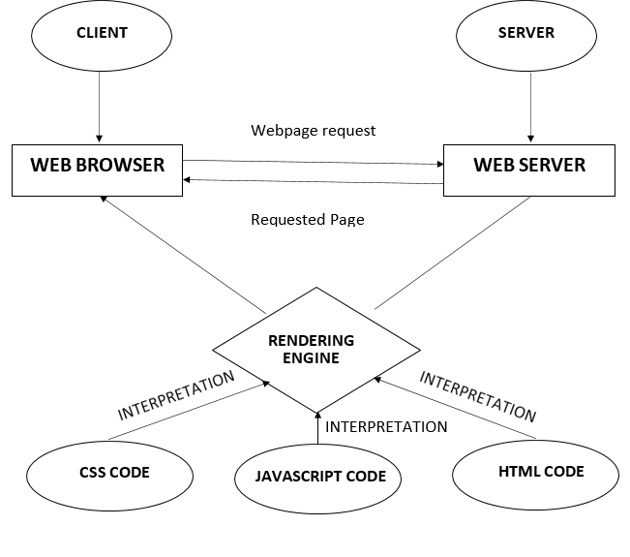

# DIAGRAM OF THE WEBSITE

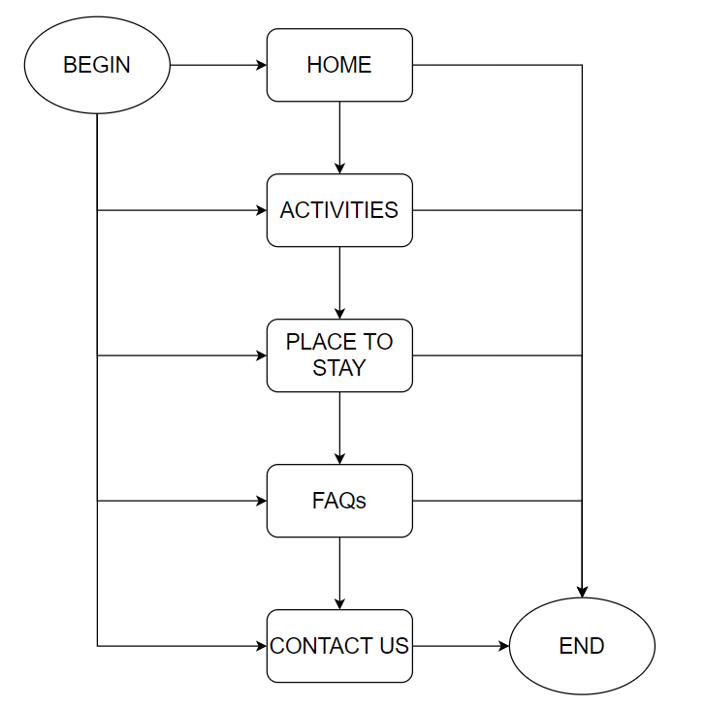

# TASK SHEET REVIEW 1

| **Project Ref. No.: eP/Advertisement Portal Management System/01** | | **Project Name** | **Activity Plan Prepared By** | **Date of Preparation of Activity Plan:** | | | |
| --- | --- | --- | --- | --- | --- | --- | --- |
| **Sr./No.** | **Task** | **Actual Start Date** | **Actual Days** | **Team member name** | **Status** |
| 1 | Problem statement | **Picnic**  **Games** | Lavi | 24-Nov-21 | 1 | Lavi | **Completed** |
| 2 | Analysis what is include Picnic Games | 24-Nov-21 | 1 | Huy | **Completed** |
| 3 | The scope of the work (in brief) | 24-Nov-21 | 1 | Quân | **Completed** |
| 4 | Architecture and design of the system | 26-Nov-21 | 2 | Huy | **Completed** |
| 5 | Diagram of the website | 26-Nov-21 | 2 | Quân | **Completed** |
| 6 | Task Sheet | 26-Nov-21 | 2 | Lavi | **Completed** |

| **Date: 26 Nov 2021** | |
| --- | --- |
| Signature of Instructor:  **Ms. Le Mong Thuy** | Signature of Team Leader:  **Sar Lavi** |

# SITE MAP

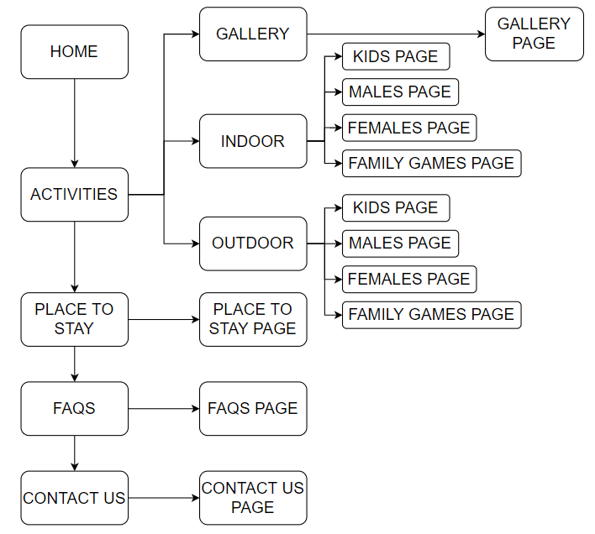

# MOCK OF THE WEBSITE

**1. HOME PAGE**

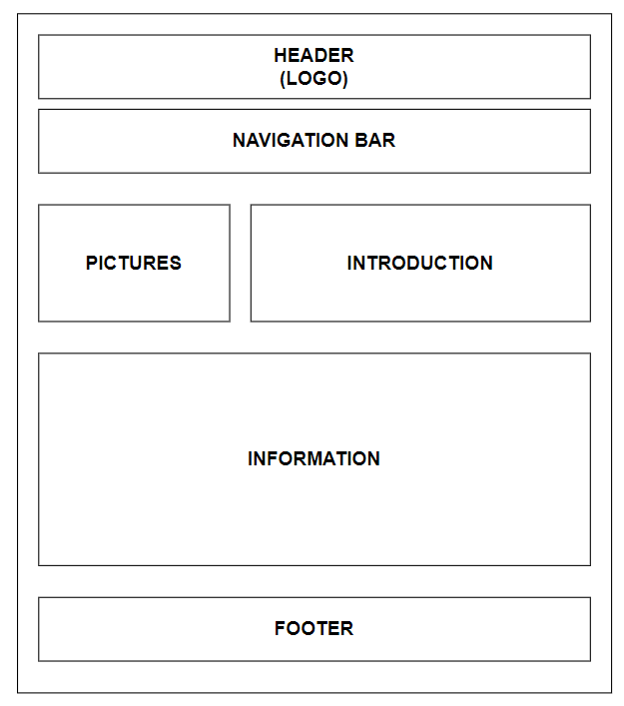

**2.1. GALLERY**

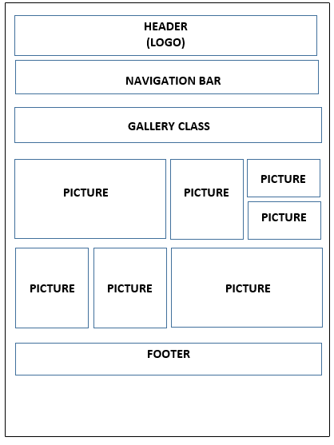

**2.2. OUTDOOR**

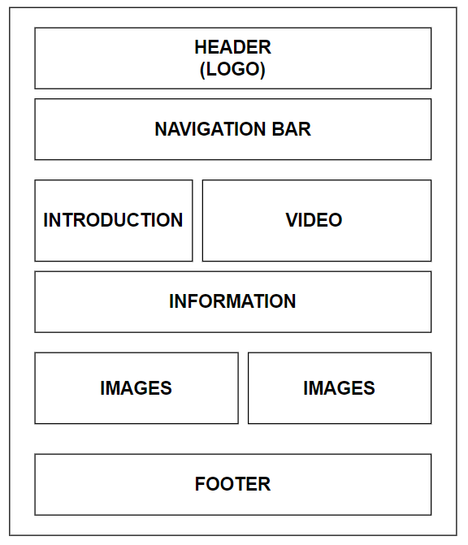

**2.3. INDOOR**



**3. PLACE TO STAY**

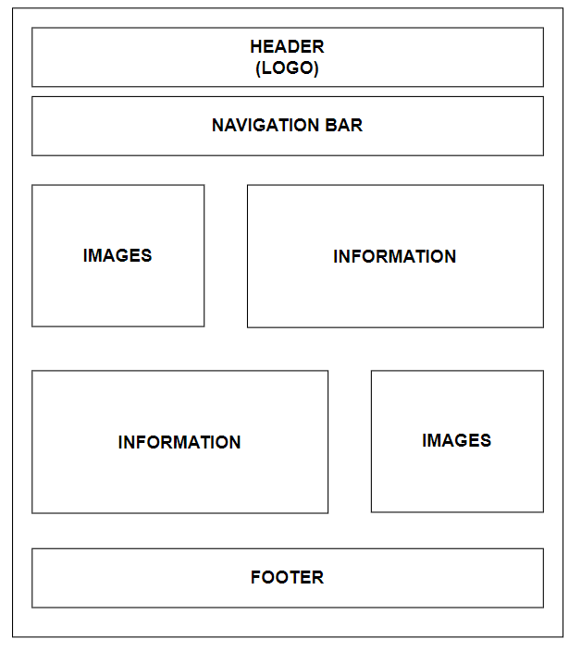

**4. FAQs**

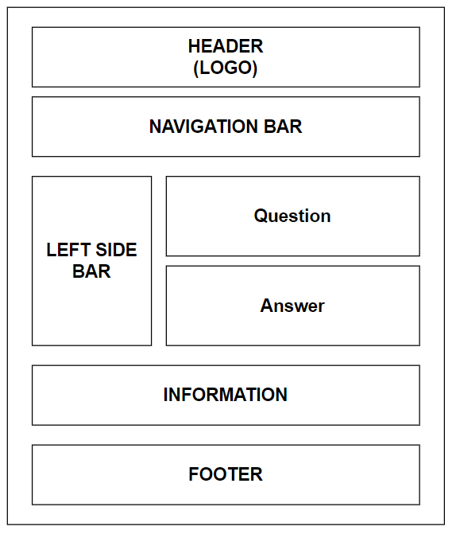

**5. CONTACT US**

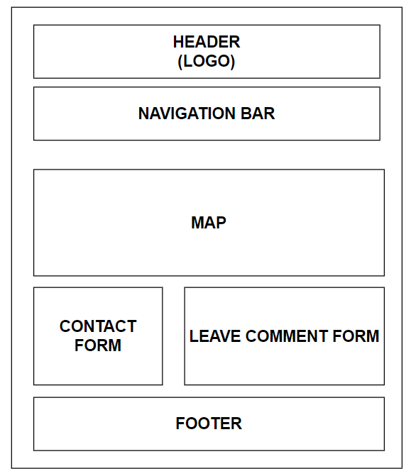

# TASK SHEET REVIEW 2

| **Project Ref. No.: eP/Advertisement Portal Management System/01** | | **Project Name** | **Activity Plan Prepared By** | **Date of Preparation of Activity Plan:** | | | |
| --- | --- | --- | --- | --- | --- | --- | --- |
| **Sr./No.** | **Task** | **Actual Start Date** | **Actual Days** | **Team member name** | **Status** |
| 1 | Site map | Picnic Games | Lavi | 26-Nov-21 | 1 | Quân | **Completed** |
| 2 | Mock of website | 26-Nov-21 | 1 | Huy | **Completed** |
| 3 | Task Sheet | 26-Nov-21 | 1 | Lavi | **Completed** |

| **Date: 26 Nov 2021** | |
| --- | --- |
| Signature of Instructor:  **Ms. Le Mong Thuy** | Signature of Team Leader:  **Sar Lavi** |

# WEBSITE DESCRIPTION

1. Home page
2. Description

Home page will display all the information that needed for picnic games and a email-register

to register for new update of the web

1. Screenshot

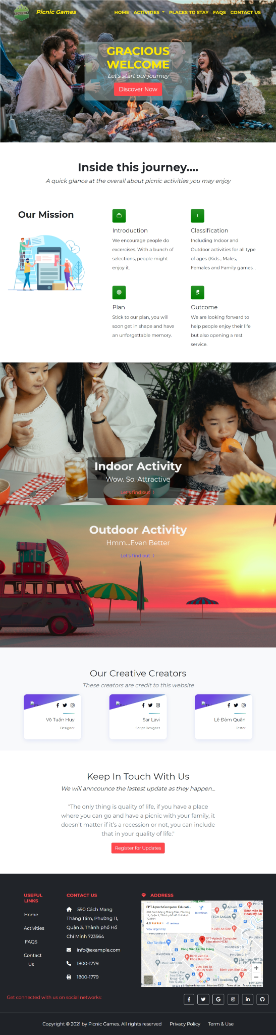

1. Activities
   1. Gallery
2. Description

Gallery page will show pictures of picnic games.

1. Screenshot

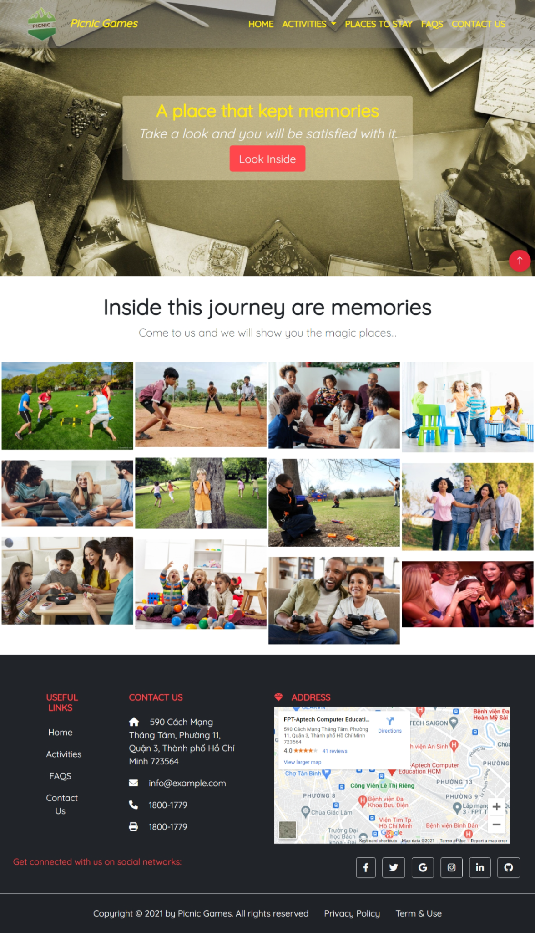

* 1. Indoor

1. Description

The indoor page show indoor games , video and categorize it with theory and customer reviews

1. Screenshot

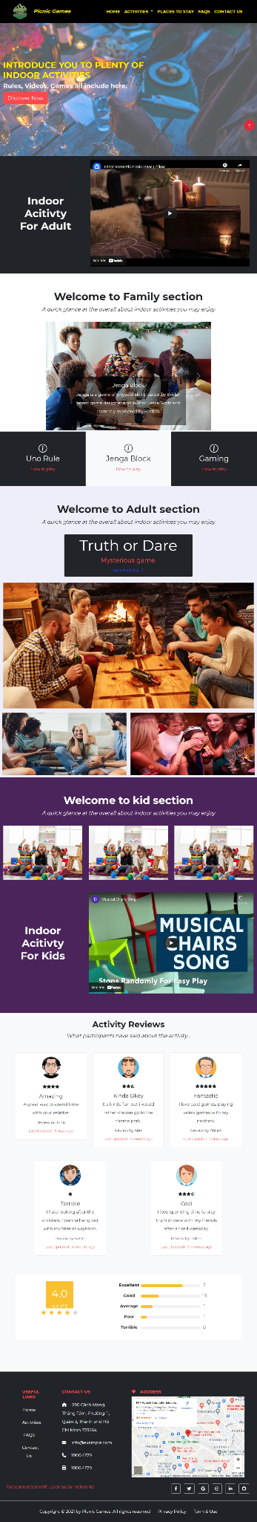

* 1. Outdoor

1. Description

This page covers game theory and classification with video

1. Screenshot

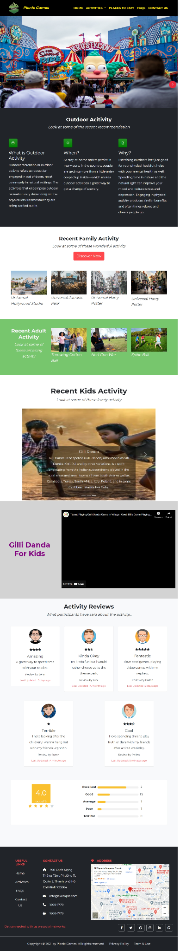

1. Place to Stay
2. Description

the place to stay page show places to stay and information attached to it

1. Screenshot

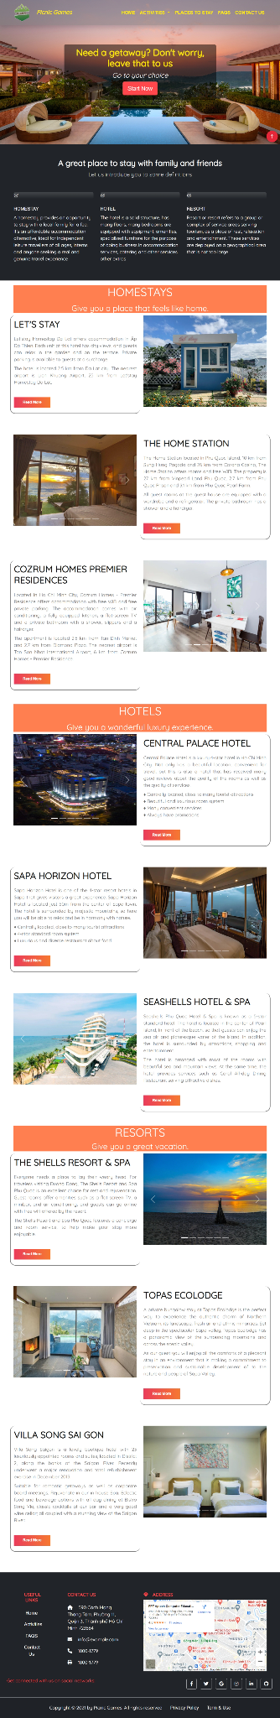

1. FAQs
2. Description

show the question and answer of customer and administrator

1. Screenshot

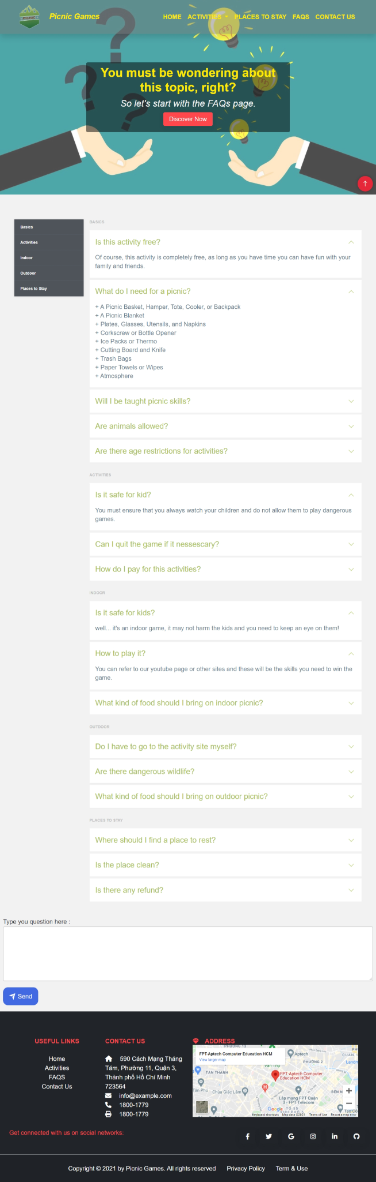

1. Example of answer frequently asked question

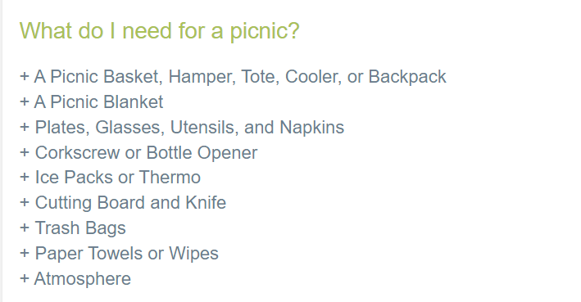



1. Contact Us
2. Description

show the map and contact chat frame

1. Screenshot

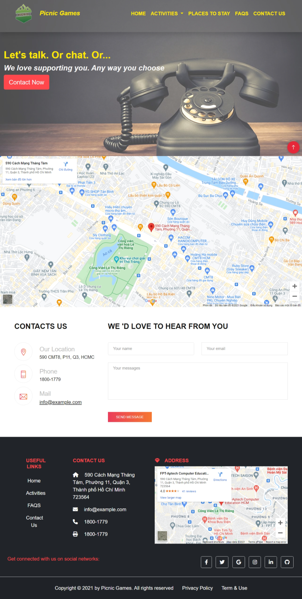

1. Example of open local mail by clicking email address

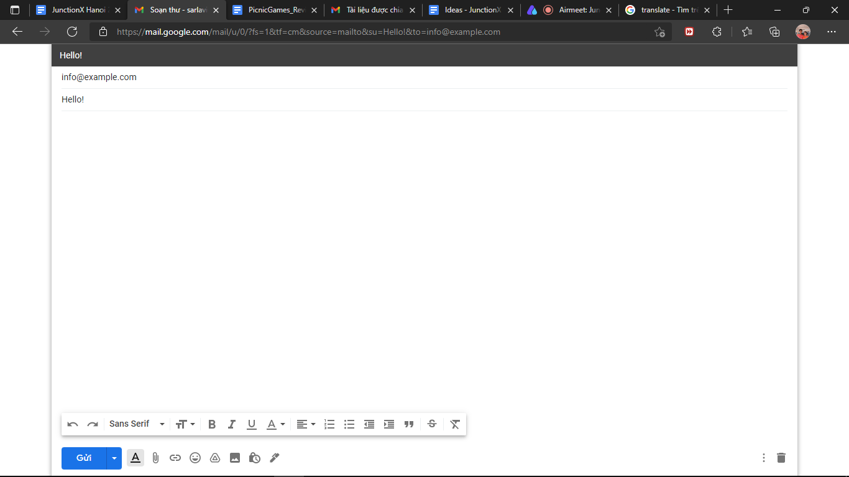

# 

# JAVASCRIPT DESCRIPTION

This chapter will provide information about JavaScript functions integrated in the website.

1. Navbar color change when scroll in home page
2. Description

This script is used to change the color of navbar from while to black when scroll down

1. Screenshot

/*Navbar Color Change When Scroll*/

$(window).scroll(function () {

$('nav').toggleClass('scrolled', $(this).scrollTop() > 300);

});

/*Navbar Color Change When Scroll End*/

2. Register email check

1. Description

This script is used to take the email user input and show it in alert

1. Screenshot

/*Register Email Check*/

function required() {

var form = document.getElementById("modal-content");

var email = document.getElementById("modal-email").value;

var pattern = /^\w+([\.-]?\w+)*@\w+([\.-]?\w+)*(\.\w{2,3})+$/;

if (email.match(pattern)) {

alert("Hello" + " " + email);

}

else {

alert("Invalid email!!!");

}

}

/*Register Email Check End*/

3. Responsive pages

1. Description

This script is used to responsive this page in many screen

1. Screenshot

(function(){

// FAQ start

var FaqTemplate = function(element) {

this.element = element;

this.sections = this.element.getElementsByClassName('cd-faq__group');

this.triggers = this.element.getElementsByClassName('cd-faq__trigger');

this.faqContainer = this.element.getElementsByClassName('cd-faq__items')[0];

this.faqsCategoriesContainer = this.element.getElementsByClassName('cd-faq__categories')[0];

this.faqsCategories = this.faqsCategoriesContainer.getElementsByClassName('cd-faq__category');

this.faqOverlay = this.element.getElementsByClassName('cd-faq__overlay')[0];

this.faqClose = this.element.getElementsByClassName('cd-faq__close-panel')[0];

this.scrolling = false;

initFaqEvents(this);

};

// FAQ end

function initFaqEvents(faqs) {

// click on a faq category

faqs.faqsCategoriesContainer.addEventListener('click', function(event){

var category = event.target.closest('.cd-faq__category');

if(!category) return;

var mq = getMq(faqs),

selectedCategory = category.getAttribute('href').replace('#', '');

if(mq == 'mobile') { // on mobile, open faq panel

event.preventDefault();

faqs.faqContainer.scrollTop = 0;

Util.addClass(faqs.faqContainer, 'cd-faq__items--slide-in');

Util.addClass(faqs.faqClose, 'cd-faq__close-panel--move-left');

Util.addClass(faqs.faqOverlay, 'cd-faq__overlay--is-visible');

var selectedSection = faqs.faqContainer.getElementsByClassName('cd-faq__group--selected');

if(selectedSection.length > 0) {

Util.removeClass(selectedSection[0], 'cd-faq__group--selected');

}

Util.addClass(document.getElementById(selectedCategory), 'cd-faq__group--selected');

} else { // on desktop, scroll to section

if(!window.requestAnimationFrame) return;

event.preventDefault();

var windowScrollTop = window.scrollY || document.documentElement.scrollTop;

Util.scrollTo(document.getElementById(selectedCategory).getBoundingClientRect().top + windowScrollTop + 2, 200);

}

});

// on mobile -> close faq panel

faqs.faqOverlay.addEventListener('click', function(event){

closeFaqPanel(faqs);

});

faqs.faqClose.addEventListener('click', function(event){

event.preventDefault();

closeFaqPanel(faqs);

});

// on desktop -> toggle faq content visibility when clicking on the trigger element

faqs.faqContainer.addEventListener('click', function(event){

if(getMq(faqs) != 'desktop') return;

var trigger = event.target.closest('.cd-faq__trigger');

if(!trigger) return;

event.preventDefault();

var content = trigger.nextElementSibling,

parent = trigger.closest('li'),

bool = Util.hasClass(parent, 'cd-faq__item-visible');

Util.toggleClass(parent, 'cd-faq__item-visible', !bool);

//store initial and final height - animate faq content height

Util.addClass(content, 'cd-faq__content--visible');

var initHeight = bool ? content.offsetHeight: 0,

finalHeight = bool ? 0 : content.offsetHeight;

if(window.requestAnimationFrame) {

Util.setHeight(initHeight, finalHeight, content, 200, function(){

heighAnimationCb(content, bool);

});

} else {

heighAnimationCb(content, bool);

}

});

if(window.requestAnimationFrame) {

// on scroll -> update selected category

window.addEventListener('scroll', function(){

if(getMq(faqs) != 'desktop' || faqs.scrolling) return;

faqs.scrolling = true;

window.requestAnimationFrame(updateCategory.bind(faqs));

});

}

};

function closeFaqPanel(faqs) {

Util.removeClass(faqs.faqContainer, 'cd-faq__items--slide-in');

Util.removeClass(faqs.faqClose, 'cd-faq__close-panel--move-left');

Util.removeClass(faqs.faqOverlay, 'cd-faq__overlay--is-visible');

};

function getMq(faqs) {

//get MQ value ('desktop' or 'mobile')

return window.getComputedStyle(faqs.element, '::before').getPropertyValue('content').replace(/'|"/g, "");

};

function updateCategory() { // update selected category -> show green rectangle to the left of the category

var selected = false;

for(var i = 0; i < this.sections.length; i++) {

var top = this.sections[i].getBoundingClientRect().top,

bool = (top <= 0) && (-1*top < this.sections[i].offsetHeight);

Util.toggleClass(this.faqsCategories[i], 'cd-faq__category-selected', bool);

if(bool) selected = true;

}

if(!selected) Util.addClass(this.faqsCategories[0], 'cd-faq__category-selected');

this.scrolling = false;

};

function heighAnimationCb(content, bool) {

content.removeAttribute("style");

if(bool) Util.removeClass(content, 'cd-faq__content--visible');

};

var faqTemplate = document.getElementsByClassName('js-cd-faq'),

faqArray = [];

if(faqTemplate.length > 0) {

for(var i = 0; i < faqTemplate.length; i++) {

faqArray.push(new FaqTemplate(faqTemplate[i]));

}

};

})();

# TASK SHEET REVIEW 3

| **Project Ref. No.: eP/Advertisement Portal Management System/01** | | **Project Name** | **Activity Plan Prepared By** | **Date of Preparation of Activity Plan:** | | | |
| --- | --- | --- | --- | --- | --- | --- | --- |
| **Sr./No.** | **Task** | **Actual Start Date** | **Actual Days** | **Team member name** | **Status** |
| 1 | Home | Picnic Games | Lavi | 26-Nov-21 | 2 | Huy | **Completed** |
| 2 | Gallery | 30-Nov-21 | 3 | Lavi | **Completed** |
| 3 | Indoor | 30-Nov-21 | 2 | Huy | **Completed** |
| 4 | Outdoor | 30-Dec-21 | 2 | Huy | **Completed** |
| 5 | Places to Stay | 30-Nov-21 | 2 | Quan | **Completed** |
| 6 | FAQs | 26-Nov-21 | 1 | Lavi | **Completed** |
| 7 | Contact us | 26-Nov-21 | 2 | Quan | **Completed** |
| 8 | Task sheet review 3 | 25-Nov-21 | 1 | Lavi | **Completed** |

| **Date: 1 Dec 2021** | |
| --- | --- |
| Signature of Instructor:  **Ms. Le Mong Thuy** | Signature of Team Leader:  **Sar Lavi** |